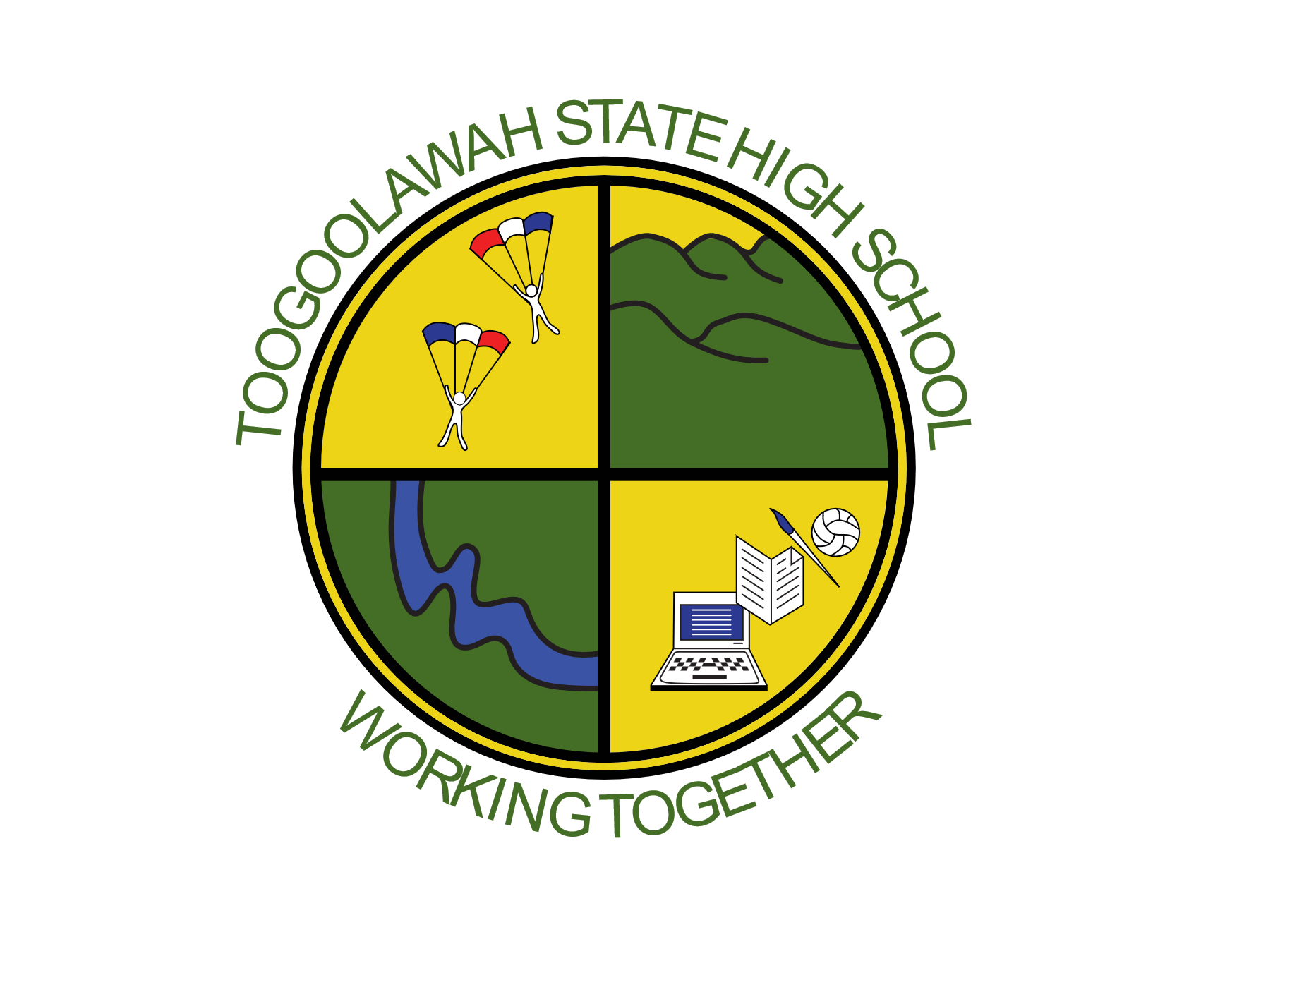
TOOGOOLAWAH
STATE HIGH SCHOOL
TUCKSHOP MENU 2026

MONDAY
Chicken Burger $5.00
Chicken & Gravy Roll $5.00
Spaghetti Bolognese * $5.00

TUESDAY
Ham & Cheese Turkish Bread $5.50
Ham, Cheese & Tomato Turkish Bread $5.50
Chicken & Cheese Turkish Bread $5.50
Term 1 Special - Chicken chips (6) $3.50

WEDNESDAY
Nachos* $5.00
Hot Dog $5.00
Toasted Ham & Cheese Sandwich $3.00

THURSDAY
Chicken Chilli & Salad Wrap $5.50
Pizza Rounders $3.00
Homemade Pizza $5.00

FRIDAY
Pork Riblet Roll $5.00
Chicken Chilli Roll $5.00
Meatball Sub $5.00

EVERY DAY
Pies $4.00
Sausage Rolls $4.00
Steak, Bacon & Cheese Pie $5.00
Assorted Sandwiches + $3.50
Ham / Chicken Salad Roll + $5.00
Ham / Chicken Salad Wrap/ Tub + $6.00
Chicken Caesar Salad Tub + $6.00
Watermelon Tub (Summer) $3.00

DRINKS
Large Assorted Juices $4.00
Small Assorted Juices $3.00
Large Flavoured Milks $4.00
Small Flavoured Milks $3.00
Flavoured Mineral Water $4.00
Glee $3.00
Iced Tea $4.00
Water $2.00

ICEBLOCKS
Zooper Dooper $0.60
Mini Calippo Raspberry $2.00
Paddle Pop Icy Twist $2.00
Flavoured Ice-cream Cups $2.00
Frozen Yogurts $2.00
Paddle Pop $2.50

SNACKS
Small Chips $1.20
Large Chips/ Popcorn $2.00
Assorted Yoghurt Tubs $3.00

To avoid disappointment, order your lunch via
FlexiSchools or visit the tuckshop team each morning!

