Student’s Name: Date:

- Students need to achieve 20 points to graduate school with a Queensland Certificate of Education.
- Students seeking an ATAR should choose the bold English, Maths and Science subjects.
- Students enrolled in VET courses delivered in partnership with an external RTOs may require VETiS funding
or need to pay a fee.
- All subjects are offered subject to departmental staffing and sufficient enrolments being received.
- Students and parents are welcome to meet with the school to discuss pathways and careers.

Choice | Subjects | Time | QCE Points | Notes
Line 1 Subject choices = please tick the box
□ | Mathematics | 3 x 70 min lessons | --- | Study this subject for ATAR pathways, Electrical Trades and some Defence Force jobs
□ | Vocational Maths | 3 x 70 min lessons | 1 QCE point | Students study the QCAA Short Course in Numeracy in Semester 1 and then in Semester 2 get a head start on Yr. 11 Essential Maths
Line 2 Subject choices
□ | English | 3 x 70 min lessons | --- | Study this subject for ATAR pathways, Electrical Trades and some Defence Force jobs
□ | Vocational English | 3 x 70 min lessons | 1 QCE point | Students study the QCAA Short Course in Literacy in Semester 1 and then in Semester 2 get a head start on Yr. 11 Essential English
Line 3 Subject choices
□ | Science | 3 x 70 min lessons | --- | Study this subject for ATAR science and health pathways, Electrical Trades and some Defence Force jobs
□ | BSB20120 Certificate II in Workplace Skills | 3 x 70 min lessons | 4 QCE points | VETiS not available  Total Cost to the school is $295 and parents are asked contribute $150 of this cost.
Line 4 Subject choices
One Year Courses
□ | Health & Physical Education | 3 x 70 min lessons | --- | ATAR in the Health or Science fields
□ | Certificate II Rural Operations | All day Wednesday | 4 QCE Points | VETiS or $2075-$4000
□ | Certificate II Hospitality | All day Wednesday | 4 QCE Points | VETiS or $560
□ | TAFE IPSWICH* please see over page | All day Wednesday | 4 QCE Points | VETIS or paid. Please see next page for details
Two Year Courses
□ | Certificate II / III in Health Services | All day Wednesday | 8 QCE points | VETIS or paid. Please see next page for details
Line 6 Subject choices
□ | Agricultural Studies | 3 x 70 min lessons | --- | Agricultural Practices provides opportunities for students to explore, experience and learn knowledge and practical skills valued in agricultural workplaces
□ | Business Studies | 3 x 70 min lessons | --- | Business Studies develops effective decision-making skills related to consumer behaviour and the management and evaluation of personal financial matters.
□ | Industrial Design and Technology | 3 x 70 min lessons | --- | The Industrial Technology Skills subject focuses on the underpinning industry practices and production processes required to manufacture products in a variety of industries,
□ | Art | 3 x 70 min lessons | --- | Art offers a diverse range of experiences in the practical and theoretical aspects of the visual arts.
□ | Home Economics | 3 x 70 min lessons | --- | Home Economics promotes preferred futures for self and others in contexts related to food and nutrition, human development and relationships, living environments and textiles.
Line 7 Subject choices
□ | Agricultural Studies | 3 x 70 min lessons | --- | As above
□ | History | 3 x 70 min lessons | --- | This subject provides a study of the history of the modern world and Australia from the 1800s to the present.
□ | Industrial Design and Technology | 3 x 70 min lessons | --- | As above
□ | Home Economics | 3 x 70 min lessons | --- | As above
□ | Drama | 3 x 70 min lessons | --- | In Drama, students: refine and extend their understanding and use of role, character, relationships and situation.
Line 8 Subject choices
□ | Tutorial | 1 x 70 min lessons | --- | Students will have 1 x 70-minute lesson to complete self-guided study
□ | CHC24015 Certificate II in Active Volunteering | 1 x 70 min lessons | 4 QCE Points | Cost to the school is $295 and cost to parents is $150
Line 9 Subjects
□ | Wednesday PDP | 1 x 70 min lessons | 1 QCE point | Students complete QCAA Short course in Career Education
□ | Monday PDP | 1 x 70 min lessons | 1 QCE point | Choose this only if you are attending Tafe or completing an all day VET course on line 4.  Students will still complete QCAA Short course in Career Education

Student’s Signature: Parent’s Signature:

Course offered under the TAFE at School Program Ipswich

Vocational Education and Training in Schools (VETiS) is a program that enables students to gain nationally recognised qualifications while at school. Students learn skills and knowledge required for specific industries.
VETiS can be undertaken in years 10, 11 and 12, and can count towards the Queensland Certificate of Education.
VET can also be undertaken while a young person is still enrolled at school through a school-based apprenticeship or traineeship (SAT).
All Certificates I and II are covered under VETiS funding. Students can also access second traditional trade funding if they choose to do a ‘hard trade’. These are:
- Construction
- Electrotechnology
- Engineering
- Automotive Vocational

Transport to TAFE is via bus and is partly funded by the school. There is a cost of $10.00 per student per day.

In Year 10, approval must be given by the school for a student to enrol in a TAFE course.

□ | VEC | Certificate II in Electrotechnology (Year 11 and 12 only and A or B in Yr. 10 Maths)
□ | VAV | Certificate II in Automotive Vocational Preparation (Light Vehicle)
□ | VRC | Certificate II in Retail Cosmetics
□ | VSA | Certificate II in Salon Assistant
□ | VCC | Certificate I in Construction
□ | VCS | Certificate II in Community Services (Childcare Stream)
□ | VKO | Certificate II in Cookery
□ | VTO | Certificate II in Tourism

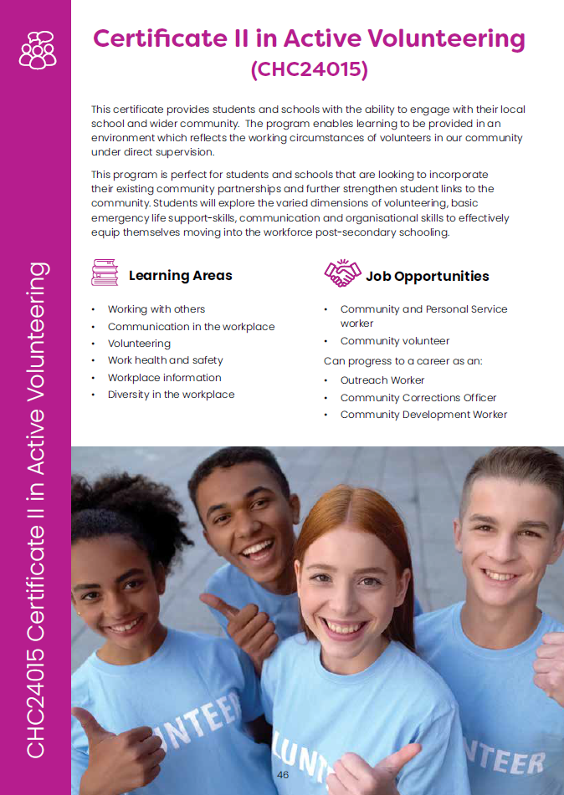



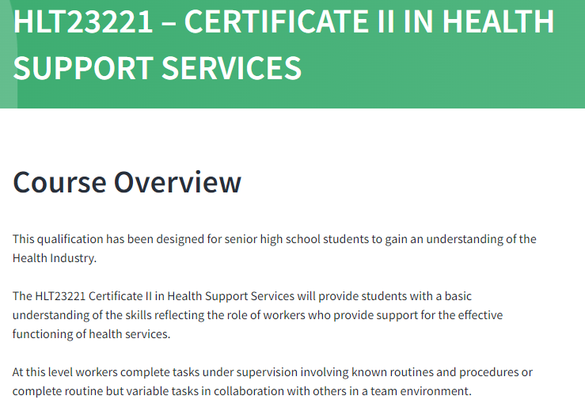
Learning Areas
- Workplace Health and Safety (WHS)
- Infection control
- Conducting basic health screening and health checks
- Health promotion and communication
- Maintaining a high standard of service
- Working with diverse people
- Supporting personal wellbeing in the workplace
- Routine stock maintenance

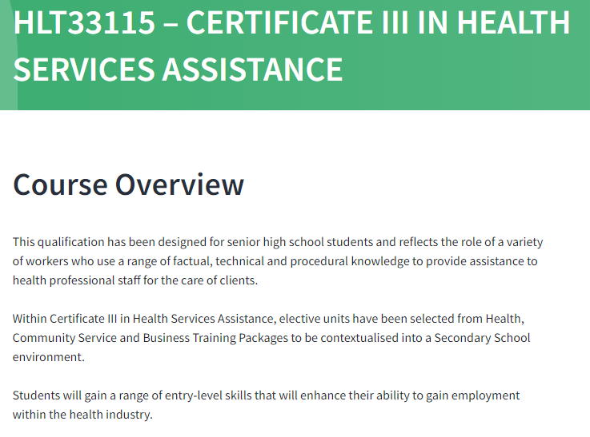

Learning Areas
- Recognise healthy body systems
- Interpret medical terminology
- Providing individualised support
- Maintain a high standard of service
- Facilitating responsible behaviour
- Promote Aboriginal and/or Torres Strait Islander Cultural Safety
- Recommended completion of at least 20 hours work experience

Certificate II in Leather Production
Leather Craft is an art that perfectly blends design and functionality. Come and learn how to take a piece of leather and then design and craft it into beautiful leather products. Our wonderfully skilled and creative trainers teach skills that can be used for making handbags, shoes, saddles and small goods.

Learning Areas
Core:
MSMENV272 Participate in environmentally sustainable work practices
MSS402051 Apply Quality Standards
MSTGN2018 Work in the TCF Industry
MSMWHS200 Work safely
MSTGN2022 Perform tasks to support production
Elective:
MSMSUP106 Work in a team
MSTGN3012 Work safely with chemicals in TCF operations
MSTGN2020 Perform test or inspection to check product quality
MSTLG2003 Perform table work
MSTLG2006 Identify materials used in leather goods production
MSTLG2007 Skive leather pieces
MSTLG3002 Cut leather by hand
MSTGN2021 Select, transfer and remove materials and products

